**Dart SDK installation**

**Step 1: Download Dart SDK from the Dart SDK archive page.**

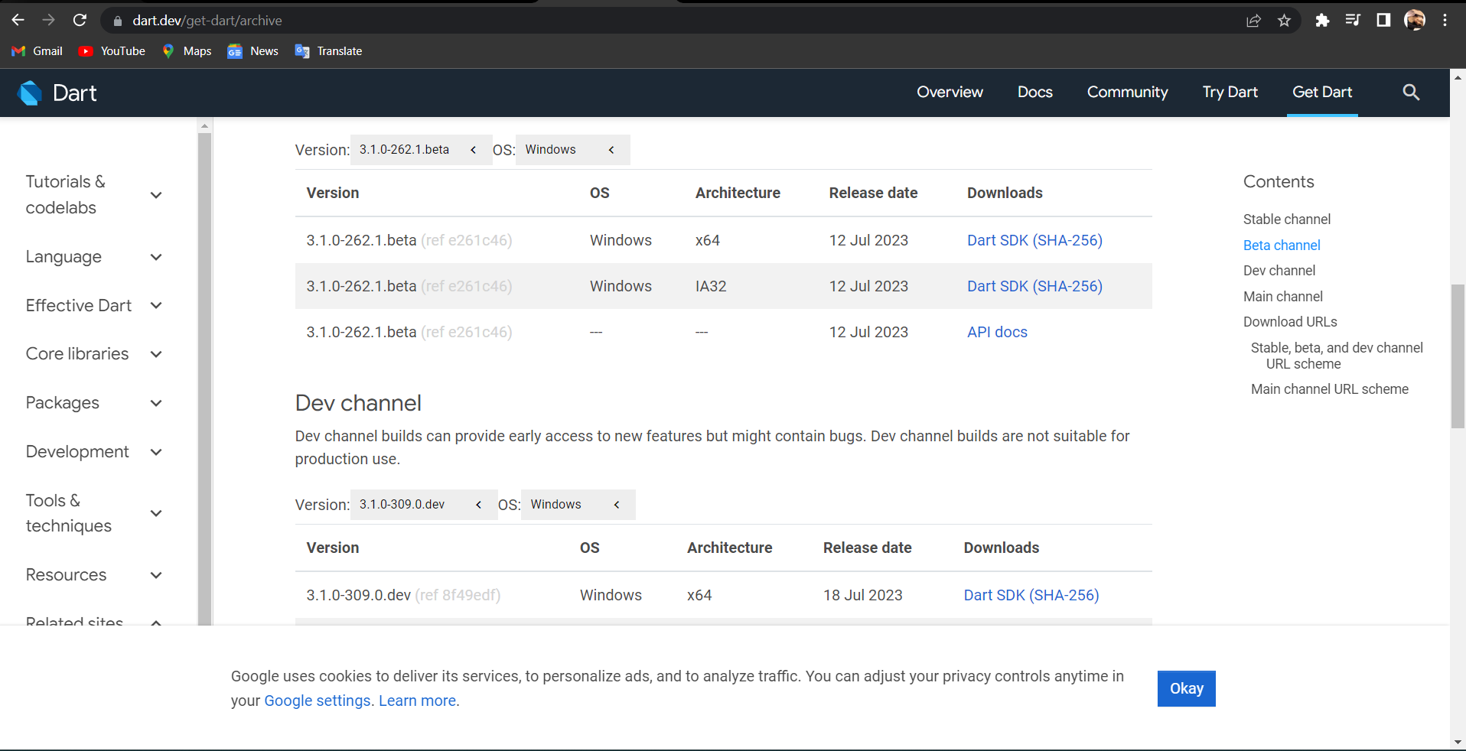

**Step 2: Extract the download Zip file. Extract the contents of downloaded zip file and after extraction contents of zip file will be as shown:**

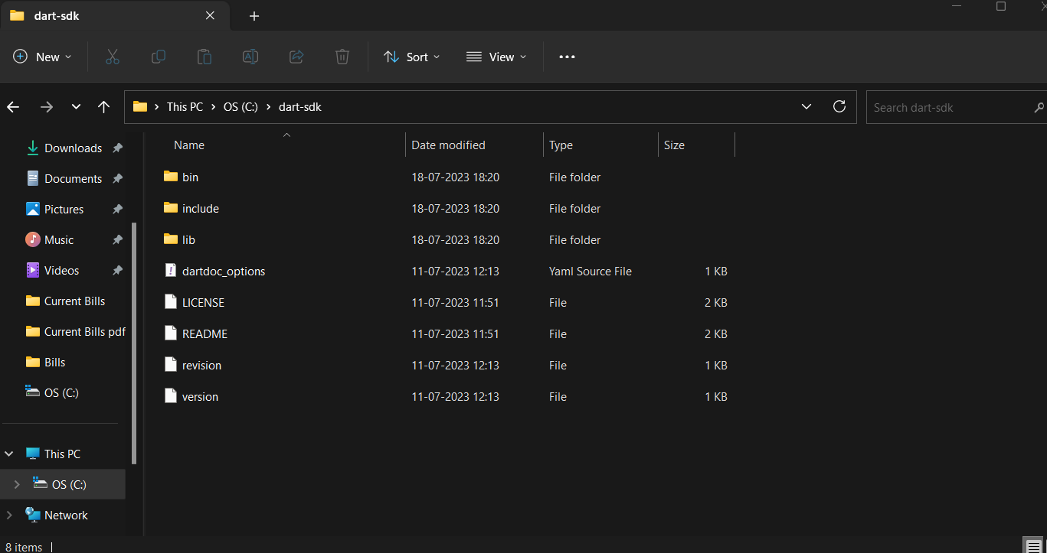

**Step 3: Open the Control Panel and search the environment variable.**

**Step 4: Setting up path in environment variables. Open Environment variable from advanced system setting and add path in system variables.**

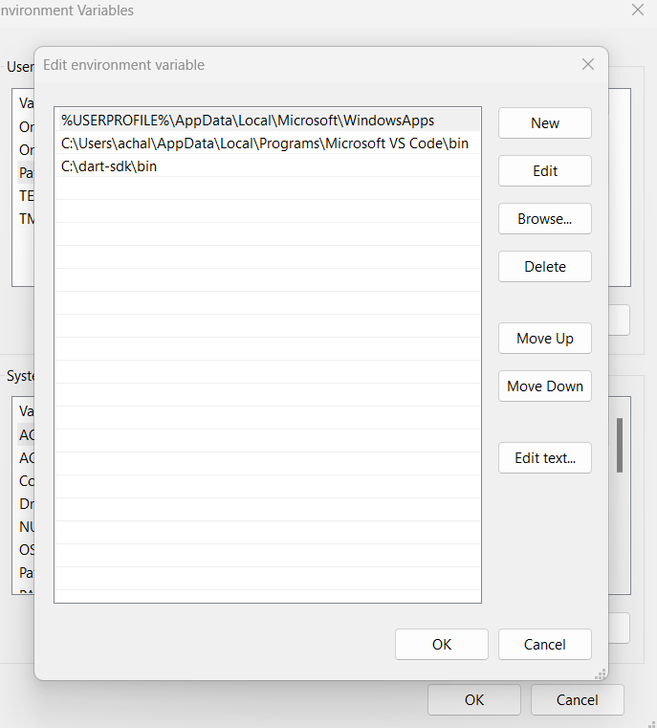

**Now we are done to use Dart from anywhere in the file system.**

**Step 5: Run Dart Using cmd.**

